HF/CB/50MHz/70MHz/VHF/UHF Full-mode SDR radio

User Manual V1.0

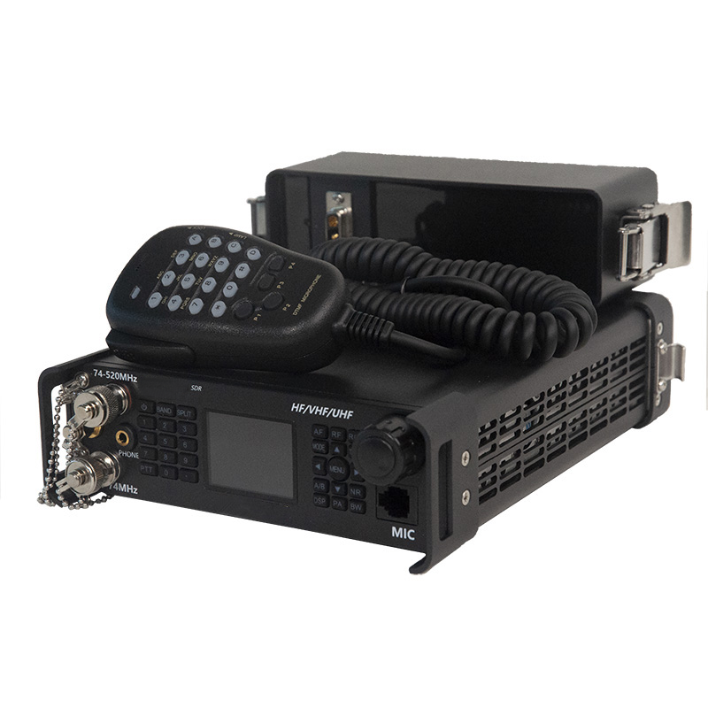

**Content**

Overview 2

Apply 2

Prompt 4

Explanation of key terms 4

Panel control and operation 4

Front panel 4

Radio button function 4

Digital hand-microphone button function 6

Encoder 7

Machine 8

Rear panel connector 8

Interface definition 9

Band selection operation 9

Band selection operation 10

AF audio settings 10

RF settings 10

USB sound card data output format settings. 11

Transmit and receive frequency offset settings 11

Sending and receiving mode settings 11

AH operation 11

A/B frequency operation 12

NR/NB noise suppression settings 12

Spectrum and waterfall chart display settings 12

Spectrum parameter display settings 12

Digital filter operation 13

Application menu actions 13

Receive advanced actions 15

Launch operation (factory locked) 16

SSB communication 17

CW communication 18

FM communication 18

Relay operations 18

FM communication 19

Relay operations 19

Customize the number pattern 19

Channel storage 20

Channel programming 20

CAT control 21

Firmware upgrade instructions 22

The CMIIT ID display 24

After-sales 25

Appendix 1: Input Methods 26

Appendix 2: Control Protocol 28

Appendix 2-1 38

Note: 40

# **Overview**

The radio is an ultra-portable full-range full-mode SDR carrier radio launched by us, with a receiving frequency of 100kHz~2GHz and an amateur transmission band covering the 160m~70cm band. The ultra-wide frequency range can realize the transmission and reception operation of all commonly used frequency bands. The radio external battery compartment design, ideal for field use, replaceable battery compartment design, dual battery backup, plus ultra-low receiving current, for ultra-long battery life. At the same time, it has a DC power interface, which can also be used for fixed stations or vehicle stations.

The machine comes with an encoder to quickly tune parameters and operating menus.

The radio operating modes include FT8, USB, LSB, CW, AM, FM, RTTY, DMR (optional), WFM (receive only). Supports all advanced functions and features of all stations.

The radio supports external 5AH battery compartment and DC port power supply. Power supply voltage range 9VDC~18VDC. At the same time, all power ports support anti-reverse polarity protection.

The display adopts a high-brightness high-resolution LCD display, and the backlight brightness is adjustable, which can also be clearly displayed outdoors. The panel adopts a full keyboard design to facilitate various operations. The keyboard backlight is adjustable to operate the station in dark environments. The encoder can quickly adjust the parameters you need, while the hand microphone with numeric keypad can control most functions of the station.

The QRadioBLE mobile app can control the radio station witlessly through Bluetooth, making the radio operation more convenient and faster. Built-in Bluetooth module, support Bluetooth wireless FT8, effectively solve the problem of wired common mode interference. The USB cable integrates a sound card and serial port, so you can control the station with a single USB cable. All amateur radio software is also supported.

The The radio has many advanced features only available in large base-based radios. This machine has dual VFO mode, split-frequency operation support, intermediate frequency offset adjustment, receive frequency fine-tuning, intermediate frequency noise suppression, AGC speed selection, RF gain adjustment, squelch control, pr-attenuator, AM broadcast reception, built-in telegram auto key, automatic key point ratio adjustment, built-in CTCSS analog sub-tone, automatic sleep function, transmit timeout function (TOT); Computer connection and computer-aided control functions, and data copying functions, etc.

In addition, The radio also has a wealth of options for selection, GPS module can achieve global positioning, timing positioning can also output positioning and timing data to other devices. The electronic compass module can be used to measure its own altitude and direction of travel.

The radio has the following features:

1. Real-time spectrum.

2. Waterfall chart.

3. Doppler frequency tracking.

4. Using software-defined radio technology (SDR), full-band support FT8, USB, LSB, CW, RTTY, AM, FM, DMR (optional),

WFM (Receive Only).

5. Dual frequency conversion circuit structure.

6. The IF width and IF displacement hardware and software can be modified to provide powerful IF interference suppression.

7. DSP digital noise reduction.

8. Built-in (4~160) m high-speed automatic antenna tuner.

9. Built-in electronic key controller, all parameters can be set flexibly.

10. Built-in sound card with IQ and audio output.

11. External battery compartment design.

12. USB TYPEC3.1 to connect to the computer

13. High-precision TXCO ± 0.5ppm (-10°C~60°C).

14. Ultra-wide working voltage range: 9~18VDC, some voltage transmission is limited

15. Power supply anti-reverse polarity protection.

16. Built-in GPS/Beidou, electronic compass (acceleration, angle sensor) (optional).

17. GPS timing (optional GPS module required).

18. The RTC clock can be set.

19. Voltage display.

20. Ultra-light weight: ≤2kg.

21. Bluetooth wireless control, Bluetooth FT8.

## Apply

Emergency communications

Remote spectrum monitoring sensing radio direction finding

Amateur radio

# **Prompt**

Please read this manual carefully before using the device, damage caused by incorrect operation is not covered by the warranty.

# **Explanation of key terms**

BAND: Band AF: Audio

# **Panel control and operation**

## **Front panel**

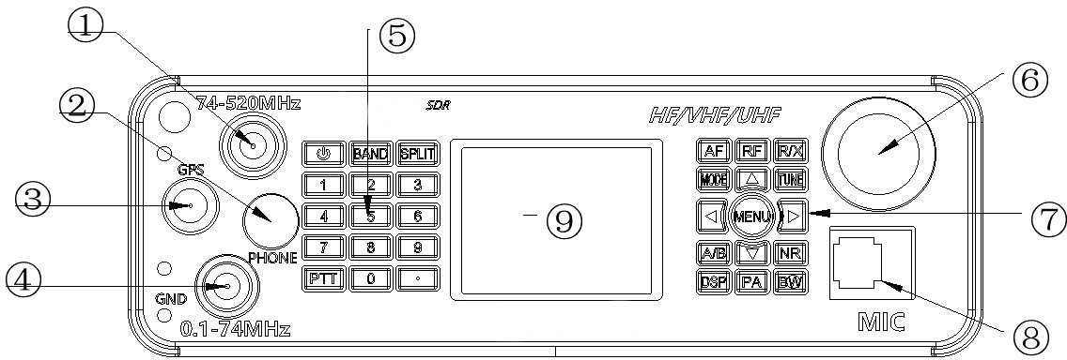

(1) UV segment antenna interface, frequency from 74~520MHz.

(2) Tactical headphone interface.

(3) GPS antenna interface for connecting external GPS active antennas.

(4) Shortwave antenna interface, frequency from 100k~74MHz.

(5) Digital button area.

(6) Encoder.

(7) Function button area.

(8) Digital hand interface.

(9) LCD screen.

## **Radio button function**

|  |  |  |
| --- | --- | --- |
| Keystroke | Short press (0.5S) | Long press (2S) |
| Power supply | Switch standing wave tables (VSWR), ALC, MIC Audio indication | Power on/ off |
| BAND | Band selection | CW settings |
| SPLIT | Off-frequency, off-frequency | Sub-tone settings |

|  |  |  |
| --- | --- | --- |
| OF | Volume, MIC gain, MIC audio flattening, bass, treble | Frequency mode, channel mode switching |
| RF | RF gain, IF gain, AGC, SQL,  THAT | USB data output format selection |
| R/X | RIT receive frequency bias, XIT transmit RF bias | Transceiver frequency bias switch |
| MODE | Mode settings | USB/LSB, NFM/WFM, CWR/CWL switching |
| TUNE | Turn on and off the weather tune | Tuning start/stop |
| A/B | A or B frequency | A=B frequency |
| NO | NB or NR selection | Show spectrum only, waterfall chart only, spectrum  Display and turn off spectrum at the same time as the waterfall chart |
| DSP | NR, NB, PEAK threshold settings | Turn off NR or NB |
| PA | Power adjustment | High and low power switching L/H |
| BW | Digital filter selection | Spectrum bandwidth settings, spectrum reference level settings, spectrum refresh rate settings |
| . | DMR settings | 5W On CW long tone emission for debugging antenna standing wave, in DMR mode, BS/MS mode switch |
| D-pad left | Left-select or impairment operations | * |
| D-pad right | Right-select or additive operation | * |
| D-pad | Upper selection | Fast frequency addition |
| D-pad down | Down-chosen | Fast frequency reduction |
| MENU | Confirm | Application interface, back |
| Digital keys 0~9 | In frequency mode, direct frequency input. In input method mode, reference key input method. | 1. For CW automatic call content 1 2. For CW Auto Call Content 2 3. For CW Auto Call Content 3 4. For CW automatic call content 4 |

## **Digital hand-microphone button function**

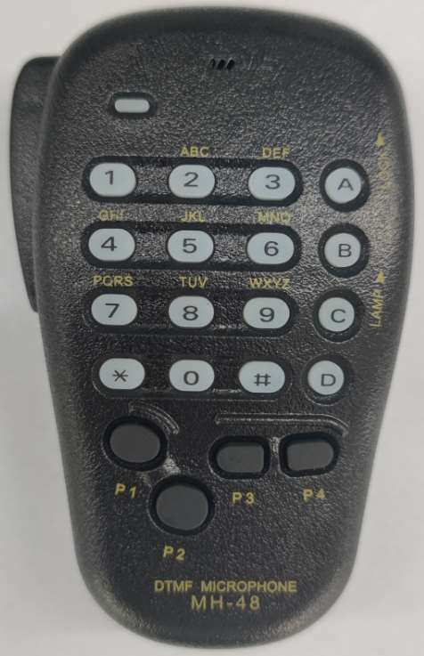

Digital key hand

|  |  |  |
| --- | --- | --- |
| **keystroke** | **Short press (0.5S)** | **Long press (2S)** |
| A | Band selection | CW settings |
| B | Mode settings | USB/LSB, NFM/WFM, CWR/CWL switching |
| C | Volume, MIC gain, MIC audio flattening, Bass, treble | Frequency mode, channel mode switching |
| D | RF gain, IF gain, AGC, SQL,  THAT | USB data output format selection |
| P1 | Digital filter selection | Spectrum bandwidth setting, spectrum reference level setting  Set and set the spectrum refresh rate |
| P2 | Confirm | Application interface, back |
| P3 | Left-select or impairment operations | * |
| P4 | Right-select or additive operation | * |
| UP | Upper selection | Fast frequency addition |
| DWN | Down-chosen | Fast frequency reduction |
| * | Turn on and off the weather tune | Tuning start/stop |
| # | NB or NR selection | Show spectrum only, waterfall chart only, spectrum  Display and turn off spectrum at the same time as the waterfall chart |
| Digital keys 0~9 | In frequency mode, direct frequency input. In input method mode, reference key input method. | 1. For CW automatic call content 1 2. For CW Auto Call Content 2 3. For CW Auto Call Content 3 4. For CW automatic call content 4 |

## **Encoder**

|  |  |  |
| --- | --- | --- |
| keystroke |  |  |
| levorotation | Impairment | Same as arrow keys down |
| Dextrorotation | Value-added | Same as arrow keys |
| Short press | Choose |  |
| Long press | Confirm (short press) | App interface, back (long press) |

**SDR main interface**

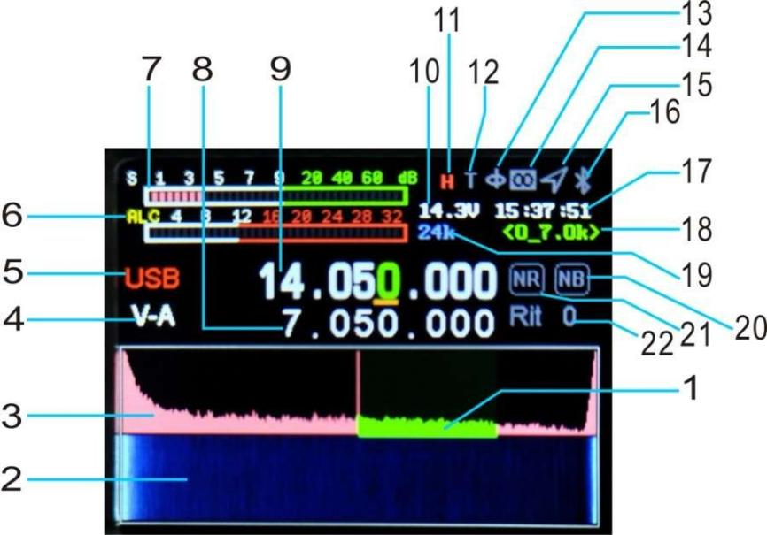

1. Digital filter.

2. Waterfall chart.

3. Spectrum.

4. Paragraph A/B indication.

5. Mode display.

6, SWR, AUD, ALC instrument.

12. AH enable display

13. Electronic compass.

14. LORA display.

15. GPS display.

16. Bluetooth display.

17. Time.

18. Digital filter bandwidth indication

7. S meter (transmit power meter).

8. Different frequency

9. Main frequency display (different receiving frequency).

10. Voltage display.

11. The high power of the radio H and the low power are L.

19. Spectrum bandwidth.

20\21, NR, NB indication.

22. RIT/XIT frequency offset.

# Machine

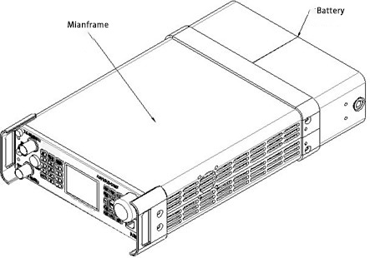

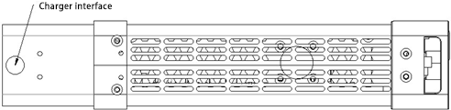

Charging port

The charging interface needs to be charged with the original charger, the charging voltage cannot be higher than 16.8V, and the charging current is 3A. non-reversible. The charging interface specification is 5.5*2.5mmDC interface.

# **Rear panel connector**

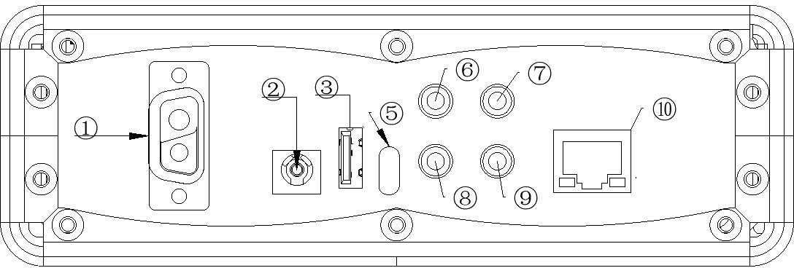

1 Battery connector.

Battery compartment interface, other types of batteries cannot be used.

2 DC power connector.

Radio power interface, specification is 5.5*2.5. Use the standard DC power cord to connect to a regulated power supply or battery. The power supply must be able to supply 6A (13.8~15) V radio full power output, UV limit below 15V, above limit UV transmission; 13.8V is recommended and more than 15 is prohibited.

3 HOST USB ports.

It is used for firmware upgrades, connecting peripheral smart devices, such as external wave wheels, keyboards, USB sticks, and is not used to charge external devices.

5 USB ports.

For USB cable connected to the computer, can output audio, digital, IQ signals. 6 Audio output interface.

Demodulated audio output for connecting external audio devices.

7 ACC interface

PTT control signal output for controlling external amplifiers and other equipment. 8 RS232 serial port.

9 Electric key interfaces.

This interface is a 3.5mm three-core connector for connecting electronic auto keys or normal hand keys. 10 Network port, reserved, non-functional.

# Interface definition

Electric keys

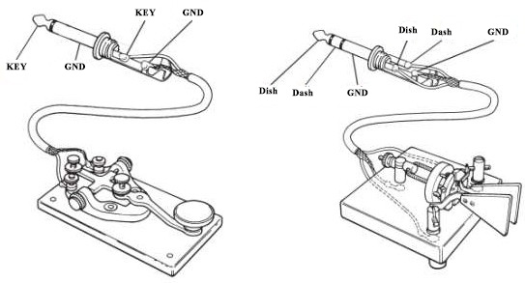

Power/charging interface

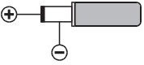

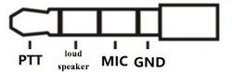Tactical headset interface definition diagram

## **Band selection operation**

Press the BAND button briefly to pop up the band selection interface, press the arrow keys to select the frequency band, and press the MENU key to confirm.

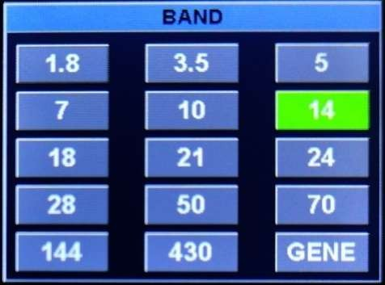

## Band selection operation

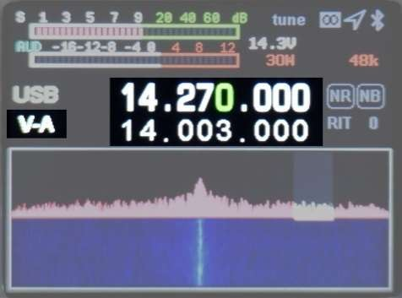Press [SPLI] briefly to display the frequency, then press off the frequency, press the left and right arrow keys to select the frequency bits, and press the up and down arrow keys to add or subtract the frequency. The upper row of frequencies is the receiving frequency, the lower row is the transmit frequency, switch and press the [A/B] button.

## AF audio settings

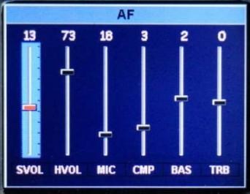Press the [AF] button to enter the AF interface, select the setting item with the left and right arrow keys, and press the keys up and down to set the value. SVOL: Volume.

HVOL: Panel headphone volume

MIC: MIC gain.

CMP: MIC compression ratio.

BAS: Bass. TRB: High

When firing you need to press PTT, and when opening the AF menu, you can adjust the bass and treble of the shot.

## RF settings

Press the [RF] button to enter the RF parameter setting interface. The left and right arrow keys select the setting item, and the up and down keys are pressed to set the value.

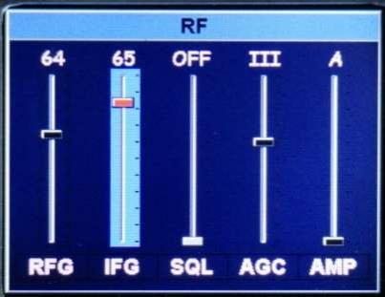

RFG: RF Gain.

IFG: IF gain.

AGC: Automatic gain adjustment speed.

SQL: Squelch level (FM mode). AMP: Pre-amplification.

Note: RFG and IFG parameters are very important for reception, these two parameters together with NR, the filter can achieve very good reception results. The RFG does not need to be set too large, generally no more than 50.

RFG, IFG factory default value is 50.

## **USB sound card data output format settings.**

Long press the [RF] button to enter the USB sound card data output format selection interface, and select the output mode with up and down keys. Press and hold again to exit.

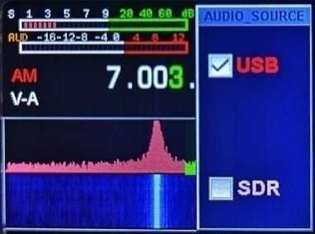 USB: FT8/HRD/N1MM/LOG32/RTTY and other digital modes are selected. SDR: Selected when using software such as CNSDR/HDSDR.

## **Transmit and receive frequency offset settings**

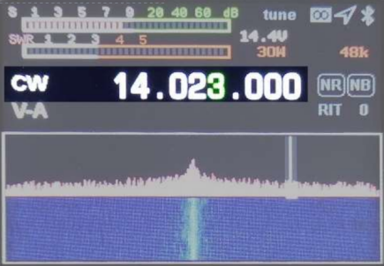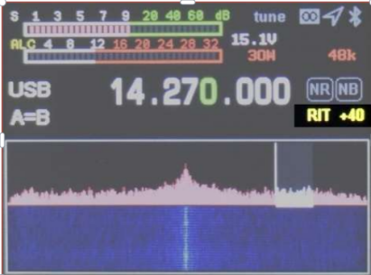Long press [R/X] to open the transmission and reception frequency offset setting interface, and then press and hold to exit. Short press to select the receive frequency bias RIT, and then short press to set the RF bias XIT. The left and right arrow keys set the frequency offset frequency. Frequency offset frequency = button display value * 20Hz.

## **Sending and receiving mode settings**

Press the [MODE] button to select the mode.

FM mode: long press to select NFM/WFM.

SSB mode: Press and hold to select USB/LSB.

CW mode: long press to select CWL/CWR

Short press to cycle through AM, FM, USB (LSB), CW, RTTY, DMR, FT8. Note: When there is no FT8 mode, select the sound card output data to USB.

## **AH operation**

1. Press the [Power] button to switch to SWR standing wave meter.

2. Press and hold the [TUNE] button, The radio will automatically enter the tuning mode, and the machine will make a short clicking sound. The T word on the display interface turns green, if you want to exit the tuning state and long press [TUNE] again, the tuning failure T is gray, the success is green, and in the green state, you can turn off the sky tune by briefly pressing [TUNE].

3. Long press [.] The radio directly into the 5W CW long tone transmission, with the standing wave of this machine to directly observe the antenna standing wave SWR value, convenient to adjust your antenna feeder system again long press the [.] key to exit.

## **A/B frequency operation**

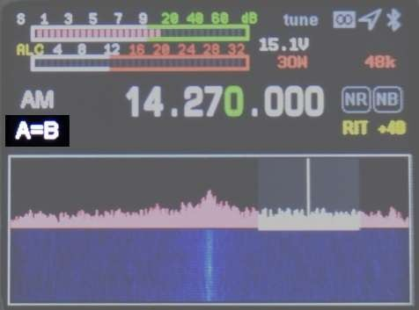Short press the [A/B] button to switch the A/B frequency, and long press A frequency = B frequency.

## **NR/NB noise suppression settings**

Short press the [NR] button to open, short press to switch NR/NB, generally use NR.

Short press the [BW] key to open the digital filter (green display) to adjust the left and right arrow keys to adjust the bandwidth ≤ 4.8K, at this time NR works, long press

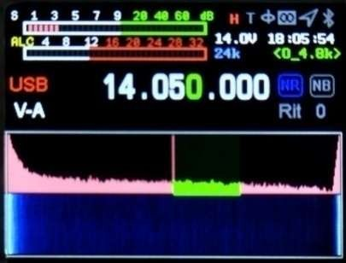

DSP key to turn off NR/NB.

Press DSP briefly to adjust the NR, NB thresholds.

## **Spectrum and waterfall chart display settings**

Long press the [NR] button to select toggle display → waterfall chart→ spectrum→ waterfall chart and spectrum display at the same time→ waterfall chart and spectrum are turned off.

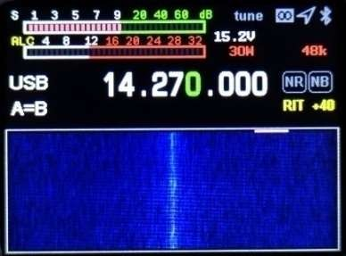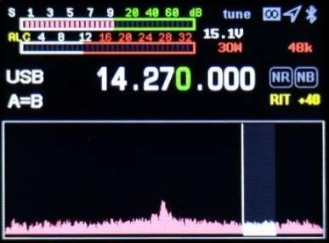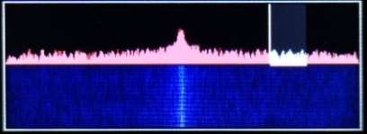

## **Spectrum parameter display settings**

Long press the [BW] button to set the spectrum bandwidth, reference level, refresh rate, direction up and down buttons to select the setting item, direction left and right buttons to set the value.

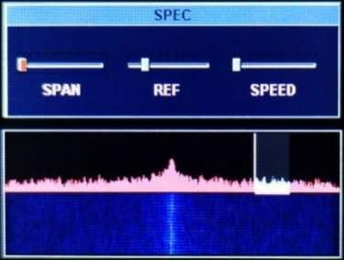SPAN: Spectral bandwidth.

REF: Spectral reference level.

SPEED: The spectrum refresh rate.

## **Digital filter operation**

Press the [BW] key to select the digital filter (green is selected in the figure below), select the filter bandwidth in the direction left and right buttons, and press the [BW] button to withdraw the filter bandwidth adjustment (the green part turns white).

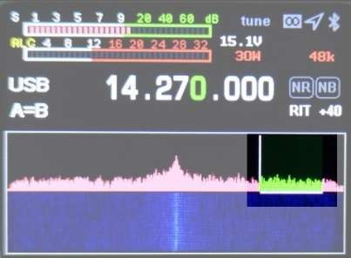

## **Application menu actions**

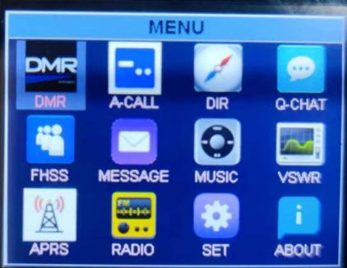Long press the [MENU] key to enter the menu interface, long press the [MENU] key to exit the menu interface, press the left and right, up and down keys to select the application, and short press the [MENU] key to select the application.

1. 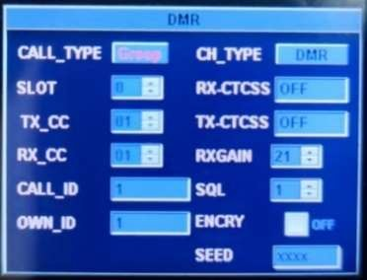DMR setting (optional)

Call type: Call type, left and right button selection.

Single: Single call

GROUP: Group Call

ALL: All Call

SLOT: Time slot, left and right button selection

0: Dual time slot, 1: time slot 1,2: Time slot 2

TX_CC: Transmit color code, left and right keys to select

RX_CC: receive color code, left and right key to select

CALL ID: Call ID, input method input

OWN_ID: Native ID

CH_TYPE: Signal Type, DMR Digital Voice Mode, DFM Analog FM Mode, Left and Right Keys to Select

RX_CTCSS: Receive Sub-tone

TX_CTCSS: Transmit sub-tones

RXGAIN: Receive IF gain, recommended value of 3

SQL: Receive squelch, currently fixed value, tuning does not work

ENCRY: encryption enabled, The radio does not support encryption

SEED: Encryption key, The radio does not support encryption

2. A-CALL automatic call settings

The contents of the auto-call settings are used for both CW auto-call and RTTY auto-call.

* 1. KEY1~KEY4: Automatic call content, up and down keys to select input items, short press [MENU] to select. Please use the radio numeric keypad or use the USB keyboard, refer to the appendix for input methods
  2. COUNT the number of consecutive calls, up and down keys to select inputs, left and right keys to adjust the number of times.
  3. DELAY Automatic call interval, in seconds. The up and down keys select the input item, and the left and right keys adjust the interval.

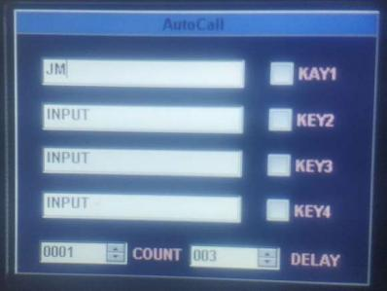2.4 In CW or RTTY mode, press and hold the number button 1~4 to automatically call the corresponding KEY1~KEY4 content.

3. GPS, electronic compass operation DIR (optional)

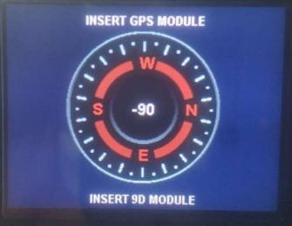 Enter the menu to directly display the UTC time, latitude and longitude, speed, direction, altitude, etc. received by the GPS module.

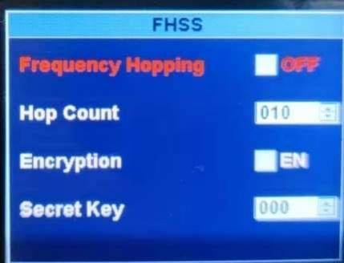4. Q-CHAT (customized)

5. Frequency hopping HFSS

Frequency hopping requires an optional GPS module and a satellite sync signal

Synchronization, frequency hopping will not begin until a valid sync signal is received. The last 10 of the channel mode

The channel is used for frequency hopping channels, and the frequency of 10 channels needs to be set to the same frequency band, otherwise the filter is switched frequently.

Frequency Hopping: Frequency hopping is enabled, left and right button selection

Hop Count: hop hops per second, currently a fixed hop number of 10 hops per second Encryption: encryption switch, left and right button selection, The radio does not support encryption Secret Key: key, The radio does not support encryption

6. TEXT MESSAGE*MESSAGE (RESERVED)

7. Music player *MUSIC.

The phone searches for the radio Bluetooth connection and uses the mobile phone music player to play audio. 8, VSWR standing wave scanning (long press MENU to exit)

7.1 Direction left and right arrow selection BABD Marker START,

Press the MENU key briefly to confirm.

7.2 BAND selects the scan band.

7.3 After the Marker is selected, press the direction left and right keys to see the band

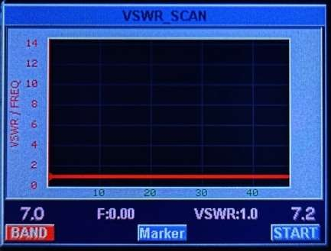 Frequency standing wave value.

7.4 START, Start scanning the antenna standing wave9,APRS（retain）

10. Set *SET

10-0 KEY-LED keyboard backlight on/off

10-1. OUT-BAND-EN OFF LOCKS THE BAND KEY BAND POOL DATA

10-2. TX-EN transmitter switch (ON needs to be turned on to launch after new machine activation)

10-3. KEY-VOLUME keyboard key volume

10-4. BACKLIGHT LCD BRIGHTNESS

10-5. LED_BRIGHTNESS Transceiver indicator brightness adjustment

10-6. HOUR Time setting: hours

10-7. MINUTE Time setting: minutes

10-8. SECOND Time setting: seconds

10-9. FAN-EN-TEMP fan temperature control

10-10. FAN-AUTO Automatic temperature control

10-11. VSWR-THRESHOLD Standing wave protection threshold OFF is an unlimited standing wave size

10-12. VSWR-TUNER sky-modulated standing wave cutoff threshold, which represents the sky-adjusted SWR to a stop below this number

10-13. TOT-TIMER Limit emission time:

10-14. AUTO-SLEEP BACKLIGHT AUTOMATICALLY TURNS OFF

10-15. VOX_EN USB port data voice on/off

10-16. VOX_THRESHOLD USB port data voice control threshold

10-17. EX_SQL Full mode squelch on/off

10-18. DBM_EN signal dbm shows on/off

10-19. GPS_TRANS Satellite data synchronization output, which can be used to synchronize the clock of external devices such as computers

10-20. FW-VERSION hardware version number

11. ABOUT

11-1. CALLAIGN call sign input (boot is displayed on the boot screen), press the MENU button on the about page to enter the input page, and press MENU to confirm the exit after entering the call sign. Press and hold MENU to exit the about page. Call sign input method: Refer to Appendix 1 Input Method.

11-2. MODEL machine model

11-3. SN machine serial number

11-4. HW hardware version number

11-5. SW software version number

# **Receive advanced actions**

The The radio is in the receiving state when it is powered on, and for a better listening experience, you need to follow me to understand the advanced operation of the machine.

1. Select the desired frequency and mode for example: 14.270MHz\USB.

2. Press the [AF] button to bring up the VOL volume adjustment, adjust the volume up and down arrow keys, adjust the appropriate volume, and press the [AF] button again to save and exit.

3. Press the [RF] button to bring up the RF parameter setting interface. Select the left and right arrow keys to select the setting item, press the up and down keys to set the value, and briefly press the [RF] button again to save and exit.

3-1 RFG: RF gain.

3-2 IFG: intermediate frequency gain.

Through the combination of RFG and IFG to achieve the highest sensitivity and lowest noise level of the receiver, usually you need to turn up these two parameters to hear very weak signals, but the noise also increases, and achieving a balanced state requires careful adjustment. In general, the IF gain can be turned on a little higher than the RF gain.

3-3 AMP pre-stage power amplifier, divided into A/B two stages.

3-4 MIC gain, if this gain is turned on too high, it will cause a large increase in pickup sensitivity, causing MIC overload, manifested as the radio press the hand microphone does not speak the transmission power out, and there is noise, so to press the hand microphone radio in the SSB no power out is just right. The recommended MIC gain is 70 and CMP is 0. The CMP must be turned off during AM mode transmission, otherwise no modulation will occur.

4. Long press the [BW] button to set the spectrum bandwidth, reference level, refresh rate, up and down buttons to select the setting item, left and right buttons to set the value, and long press again,

[BW] key to exit. Other signals within the bandwidth can be seen through the spectrum display.

4-1 SPAN: spectrum bandwidth, 1.5K, 3K, 6K, 12K, 24K, 48K width, respectively.

4-2 REF: spectral reference level.

4-3 SPEED: spectrum refresh rate.

5. Spectrum and waterfall chart display settings.

Long press the NR key to select to display the waterfall chart, long press to select the spectrometer, long press the tile chart and the waterfall chart to display at the same time.

6. Digital filter operation, The radio provides powerful digital filter.

Press the BW key short to select the digital filter, after selecting the digital filter, the original white horizontal line on the spectrometer is displayed in green, the left and right buttons select the filter bandwidth, and press the BW button again to determine the filter bandwidth exit. Different bandwidth widths can effectively avoid interference signals to achieve excellent listening results.

7. NR/NB noise suppression setting, usually this option must be combined with the digital filter to achieve excellent results.

7-1. Press the [NR] button to turn on, and short press to switch NR/NB. Press and hold the DSP key to turn off NR/NB. Press [DSP] to set the NR/NB/PEAK threshold, select the NR/NB/PEAK setting item with the up and down keys, set the value with the left and right keys, and briefly press [DSP] again to exit.

7-2 find the required signal, turn on NR, usually the effect of NR is more obvious, and then press ○6 operation to open the digital filter to the maximum bandwidth, and then adjust the digital filter bandwidth little by little, adjust to 4.8K when you will find that the noise will be greatly suppressed, at this time you can also adjust the previous RFG and IFG combination to achieve the optimal reception effect.

With the above settings, you have mastered the advanced reception settings of the The radio, and now, let the The radio swim with you in the ocean of radio waves.

# **Launch operation (factory locked)**

TX opening method: Long press MENU - arrow keys to select SET - tap MENU - find TX-EN - left arrow key to select ON - long press MENU to exit - long press MENU again to exit the menu interface.

Follow my guide on how to quickly set up and use your new The radio. You'll love to use it to communicate, and we'll walk you through your first QSO and you'll get an unparalleled experience from this brand-new walkie-talkie. Now, let's start to find out how!

**Turn The radio on and off**

1. If you want to turn on the walkie-talkie, just press and hold the power button for 3 seconds.

2. If you want to turn off the walkie-talkie, just press the power button for 3 seconds.

3. The radio has the function of saving power off data, for example, you operate power off on 7.050Mhz LSB.

after the power is turned on again, there is no need to go through the power switch, and the state before the power off will be directly restored, this function is conducive to choosing remote control operation.

Band selection

1. The frequency range of The radio is very wide, press the [BAND] button to bring up the band menu.

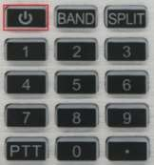2. Press the arrow keys to select, and press [MENU] to confirm the frequency band.

Frequency selection

1. Press the left and right arrow keys to select the position of the cursor and press shortly

The up-arrow keys adjust the required frequency, and long press goes up and down

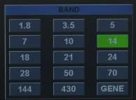 key to quickly select the desired frequency.

2. Direct numeric keypad input required frequency.

For example, if you want to enter 14.270Mhz, press 014270000

or 14.270000 on the numeric keypad respectively, and then press

the menu key [MENU] to confirm.

Mode selection

1. The radio supports FT8, LSB, USB, CW, FM, RTTY. short press the [mode] button to select, LSB and USB need to long press the [mode] key to switch, and CW and CCR long press the [mode] key to switch. WFM and NFM need to long press [MODE] to switch.

Transmit power selection

1. Press [PA] briefly to enter the transmission power adjustment, and adjust the value with the up and down arrow keys.

2. Long press [PA] to quickly select 5W and 20W segments, and each segment can be finely adjusted by the up and down arrow keys.

Receive volume, MIC gain

1. Press the [AF] button to enter the AF interface, select the setting items with the left and right arrow keys, and press the keys up and down to set the value.

SVOL: volume; HVOL: The volume of the headphones in the front version

MIC: MIC gain

CMP: MIC compression to width ratio.

BAS: Bass.

TRB: High pitch.

Hand settings

1. When choosing a wire hand, insert it directly into the front panel MIC port.

2. When the wired hand is connected to the radio, the MIC gain can not be adjusted too large, if the wired hand device PTT is pressed under SSB without speaking and environmental noise, if the radio power meter has an output, the hand gain is too large, and it needs to be reduced to press the hand microphone in a quiet situation without any power output.

After the simple setup is completed, you can now communicate happily, usually LSB mode below 7Mh, USB mode above 14Mhz, and FM mode above 28Mhz. Please check your radio license before launching, comply with local laws and regulations, The radio will be locked (no transmission) before leaving the factory, please open it yourself after complying with the law.

**FT8 communication**

1. Press the [MODE] key, select FT8 mode, use USB cable to connect to the computer, open FT8 software, select CAT protocol device as FT-817, audio device as The radio, other parameters default.

2. When using Bluetooth for wireless FT8, you first need to connect the radio station like a Bluetooth headset, use the mobile phone to scan the Bluetooth device, connect this device when the headset icon name is The radio-BT, and then open the FT8CN software, select Bluetooth in the software and select The radio-BT. Refer to the Software Usage Instructions for use of the Software. Bluetooth FT8 is the recommended way to completely avoid common-mode interference caused by antennas.

# **SSB communication**

1. Press the [MODE] button to select one of the SSB (LSB or USB) modes. If you are operating in the 7MHz band or below, select LSB mode. If you are operating in the 14MHz band or above, select USB mode.

2. Press the [Power] button shortly, and the screen switches to ALC, SWR, AUD instrument display.

3. Press the PTT button on the microphone to speak with the normal voice microphone while observing the ALC instrument display. When the microphone inputs the actual voice level, the corresponding amplitude will be displayed on the ALC meter. Release the PPT button to return to receive mode. If you find that the voice is distorted, you can turn off the CMP and adjust the MIC gain to about 70.

4. If the ALC meter display is too high or too low, you can reset the gain value of the microphone as follows: long press the [AF] button for one second, enter the selection mode, select the MIC item in the left and right directions, set the value with the up-arrow key, and press and hold the [AF] key again to exit. The microphone speaks until the ALC is displayed when your voice peaks

# **CW communication**

When using hand keys, auto-keys, semi-automatic keys, external electronic keyers, or computer-generated keyboard devices, follow these steps:

1. Insert your 3.5mm (3-phase or 2-phase) plug into the KEY jack on the back panel.

2. Short press [MODE] to select a CW mode (CW or CWR), "CW" mode uses the carrier input on the USB side, and CWR (reverse) mode uses the input on the LSB side.

3. Long press the [BAND] button to enter the CW setting. The keyboard up and down arrow keys select options, and the left and right arrow keys adjust the settings within the options.

3-1, KEY MODE Left and right arrow key selection content: manual electric key Automatic electric key

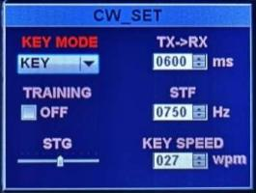3-2. KEY SPEED Automatic key bit-rate the larger the value, the faster the speed

3-3. TX-RX CW transmit and receive conversion time, the larger the value, the greater the delay.

3-4, STF CW side-tone audio.

3-5. STG CW side-tone volume.

* 1. , TRAINING practice mode, do not turn on launch.
  2. , DECODE CW, RTTY decoding display switch.

3-7, THERSHOLD CW decoding threshold.

4. CW automatic call, long press the [MENU] key to enter the MENU menu, select A-CALL with the arrow keys, short press the [MENU] key to select A-CALL, and use the numeric keypad or USB keyboard to enter the automatic call content. Press and hold the [MENU] key continuously to exit the main interface, set the electric key mode to the hand key KEY mode, and long press the numeric keypad 1~4 corresponding to the 4 pieces of content entered.

# **FM communication**

The radio supports full-band FM mode transmission and reception, usually used for FM communication above 28Mhz in shortwave communication, 29.6Mhz is called the magic band by the HAM community, and it will be opened for a short time in the summer of the year, which is a very challenging communication.

1. Press the [MODE] button to find the FM mode, and long press the [MODE] button to switch WFM mode and NFM mode.

2. The radio contains UV segment FM, you can communicate with ordinary walkie-talkie, you can also go to the local repeater.

3. Press the [RF] key shortly, select SQL and squelch options with left and right arrow keys, and set the squelch level with up and down arrow keys.

# **Relay operations**

1. Set the required frequency, such as repeater parameters (downlink 145.670Mhz, uplink 144.130Mhz, uplink analog mute 88.5) set as follows:

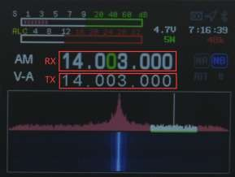 1-1, press SPLI to display the frequency of the off-course, and then press to turn off the off-frequency frequency, the frequency in the upper row is the receiving frequency, that is, the relay downstream, press the left and right arrow keys to select the frequency bit, press the up and down arrow keys to add and subtract the frequency, or directly enter the numeric keypad: 14567000, the frequency in the lower row is displayed as the transmit frequency, that is, the relay upstream frequency, you need to press the A/B key to switch to the upper row, directly enter 14413000 on the keyboard, and then press the A/B key to switch to the lower row.

1-2. Dumb setting method, long press [SPLIT], up and down keys to select setting items, left and right keys to select parameters.

T-CTSS transmits sub-tones

R-CTSS receives sub-tones

L-Voice preamble rate:

L-Time preamble duration

# **FM communication**

The radio supports full-band FM mode transmission and reception, usually used for FM communication above 28Mhz in shortwave communication, 29.6Mhz is called the magic band by the HAM community, and it will be opened for a short time in the summer of the year, which is a very challenging communication.

1. Press the [MODE] button to find the FM mode, and long press the [MODE] button to switch WFM mode and NFM mode.

2. The radio contains UV segment FM, you can communicate with ordinary walkie-talkie, you can also go to the local repeater.

3. Press the [RF] key shortly, select SQL and squelch options with left and right arrow keys, and set the squelch level with up and down arrow keys.

# **Relay operations**

1. Set the required frequency, such as repeater parameters (downlink 145.670Mhz, uplink 144.130Mhz, uplink analog mute 88.5) set as follows:

1-1, press SPLI to display the frequency of the off-course, and then press to turn off the off-frequency frequency, the frequency in the upper row is the receiving frequency, that is, the relay downstream,

press the left and right arrow keys to select the frequency bit, press the up and

down arrow keys to add and subtract the frequency, or directly enter the

numeric keypad: 14567000, the frequency in the lower row is displayed

as the transmit frequency, that is, the relay upstream frequency, you need to

press the A/B key to switch to the upper row, directly enter 14413000 on the keyboard, and then press the A/B key to switch to the lower row.

1-2. Dumb setting method, long press [SPLIT], up and down keys to select setting items, left and right keys to select

**parameters.**

T-CTSS transmits sub-tones

R-CTSS receives sub-tones

L-Voice preamble rate

L-Time preamble duration Select [USB] digital mode.

1-3. At this time, you can search on the frequency, if there is an RTTY signal, the relevant computer software can decode it. 2. Radio independent RTTY communication:

* 1. SHORT PRESS THE [MODE] BUTTON TO SELECT RTTY MODE.
  2. Press and hold the [BAND] button to turn on the DECODE decoding display.
  3. Connect the USB keyboard to the HUSB port, press the keyboard TAB key to launch, the keyboard can enter characters to launch, press the TAB key to stop the launch.

3. RTTY automatic call.

Press the [MODE] button to select RTTY mode. Long press the [MENU] key to enter the MENU menu, select A-CALL with the arrow keys, short press the [MENU] key to select A-CALL, and use the numeric keypad or USB keypad to enter the automatic call content. Press and hold the [MENU] key continuously to exit the main interface, and long press the numeric keypad 1~5 corresponding to the 5 pieces of content entered.

# **Customize the number pattern**

The radio works with the mobile APP software HAM-BOX to realize a custom digital communication mode, which requires the same settings on both sides of the communication.

1. Find the Bluetooth of the mobile phone to search for The radio and pair it to connect.

2. Open the mobile phone APP software HAM-BOX and set the relevant communication mode (both communication parties need to be the same). Then the phone operation sends text, pictures, coordinates, etc.

The software is provided separately with the The radio instructions and can be removed from the Q group.

# **Channel storage**

1. Press and hold AF to enter channel mode

2. Long press the left and right arrow keys to make the number (channel number) next to CH turn red, short press MENU to turn green, and press the up and down arrow keys to operate the channel mode when the channel number is green.

3. In channel mode, press the up and down arrow keys to save the channel (or the existing channel is covered again) At this time, there is the word RENAME. Long press the right arrow key RENAME to turn red, and press MENU to come out of the channel name input box.

3-1. Input method: At present, only letter and number symbol input is supported, and Chinese input post-production.

3-2. Long press the number 1 key to switch uppercase letters, lowercase letters, numbers and symbol input, and short press the MODE delete key.

3-3. In the symbol,..? Next, press the decimal point on the left key disk, press once, and press twice...... The characters are [,.?! :;

'" () < > [] {} $% @ * + - = ~ 】 and so on, remember that Jane presses continuously, if the press is wrong, click MODE to delete the last input.

3-4. In the letter state, the number key 2 short press 1 time is A, short press 2 times is B, 3 times is C, the lowercase is the same.

2=ABC 3=DEF 4=GHI 5=JKL 6=MNO 7=PQRS 8=TUV 9=WXYZ

3-5. In the digital state, correspond to the corresponding numbers. After the input is completed, press MENU to confirm, at this time, adjust the frequency, mode, and other corresponding parameters on the interface, and automatically save the shutdown.

4. Enter the next set of channels to repeat the above operation.

# **Channel programming**

The The radio supports programming of radio channels using PC-side software.

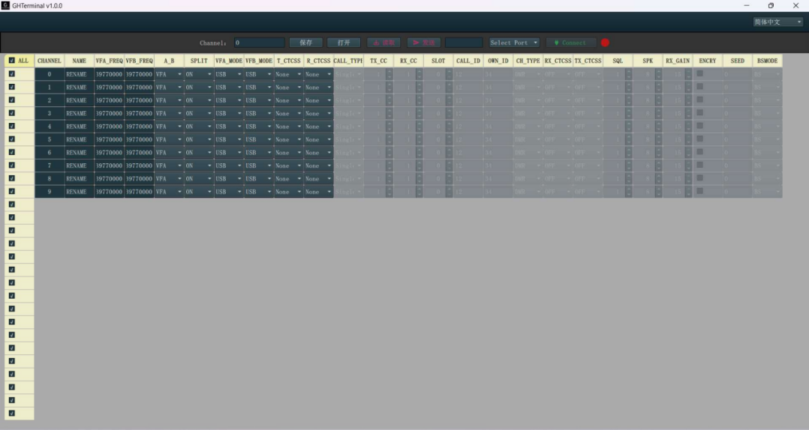

Click Select port to select the serial port number of The radio, then click connect, the connection will show green, and then click to read all the channel data of the station, edit the channel that needs to be edited after reading, pay attention to the frequency unit is HZ, be sure to enter the full number of digits, other parameters refer to other parts of the user manual to explain, after editing the channel, click send to write the channel to the station. Click Save to save the edited channel as a file, which can be copied directly to other stations. Click Open to open the saved channel file.

# **CAT control**

The radio compatible with CAT protocol:

The The radio has a CAT system, so you can control the walkie-talkie from a personal computer. Multiple control operations can be performed fully automatically with a mouse click, and third-party software packages (e.g. radio log software for matches) are also supported, eliminating the need for (additional) operators to communicate with the The radio. CAT protocol is compatible with FT-817/FT847UNI, so select FT-817/FT847UNI radio model when controlling CAT, usually only need to determine the corresponding COM port number on the computer side, stop bit, baud rate does not need to be set.

CAT control can be connected to the computer using a TYPE-C USB CABLE, and the serial port driver is only suitable for WINDOWS 10 SYSTEMS. The USB cable also integrates the sound card function, and only one USB is required to realize CAT control and data transmission. Due to the variety of various computers, operating systems, and various application software, we does not develop system control software. However, the The radio widely supports a variety of third-party control software packages.

The radio CAT protocol:

The radio supports independent own protocol, all interface of the protocol is open, can be freely developed, and can provide technical support. The agreement is set out in appendix 2.

**Firmware upgrade instructions**

# **Firmware upgrade instructions**

**Illustrate:**

Copy the application FW-NEW. bin to a USB stick and insert it into the HUSB port behind the radio to update the application. Bootloader file name and application file name naming rules:

Application file naming convention: Fixed file name FW-NEWW.bin.

Note: The file name of the application cannot be changed or the boot loader will not recognize it.

BootLoader file name and application storage method: Application FW-NEW.bin can only be stored on a USB stick used for firmware upgrades.

The size of the USB flash drive needs to be less than or equal to 8G, and the BootLoader cannot recognize the USB flash drive beyond 8G.

Document reading instructions: The items listed in this document are important items and must be carefully read and paid attention to. All operations need to be read and mastered before operation. This document comes with how-to videos, please review the documentation and videos carefully.

Radio updates the app.

Insert the USB flash drive of the storage application FW-NEW. bin into the HUSB port of the radio, press and hold the power button, and the Bootloader of the radio will automatically recognize the application to the USB flash drive and update it automatically. The radio screen will indicate the progress of the update, and when the update 100% is displayed, remove USB drive to reboot, the automatic update is complete. Unplug the USB flash drive, press and hold the power button to turn on the computer, and you will automatically enter the main interface of the station. If the update fails, the radio screen prompts you with an error code and failure information. Check whether the USB flash drive capacity or FW-NEW.bin file name is correct, or copy the FW-NEW.bin to the USB flash drive to re-update the application after replacing the USB flash drive.

**Note:**

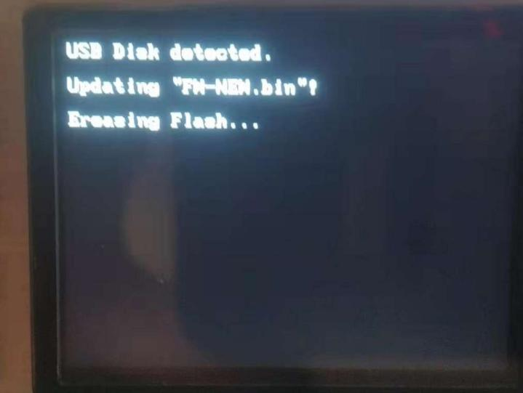1. After the update is completed, you cannot insert the USB flash drive again, otherwise the application will be updated again.

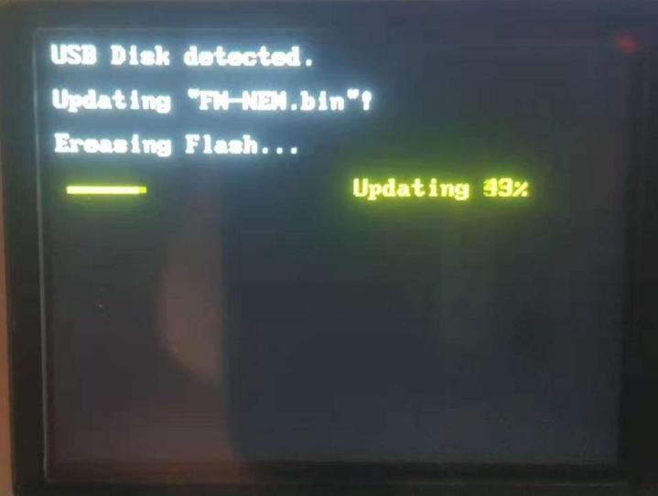

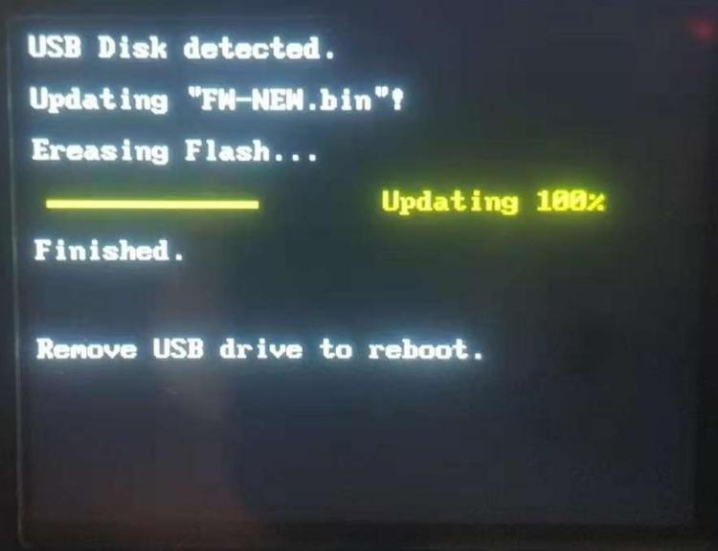

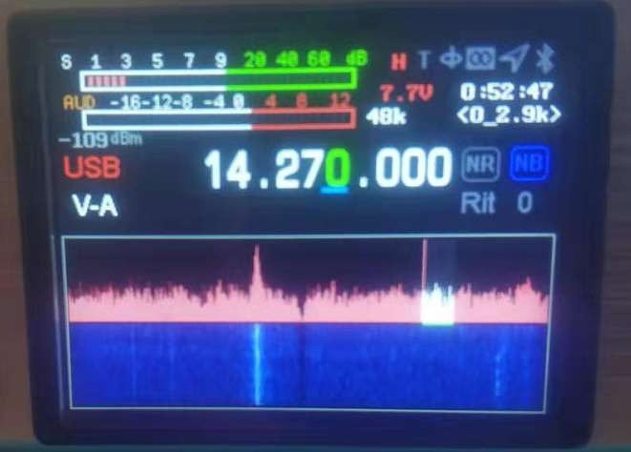

Complete the application upgrade.

# **The CMIIT ID display**

# **After-sales**

1. After product activation, no reason return is supported.

2. If there is a quality problem within 15 days of the product, the appearance is not damaged or scratched, and the same model can be replaced. It needs to be sent within 3 days from the date when the manufacturer is clearly informed, and it will be deemed invalid if it expires! Courier fees are borne separately.

3. Product packaging, cables, documents and gifts and other accessories are not covered by the warranty.

4. The product will be repaired free of charge within 12 months from the date of sale, (except for man-made or improper operation damage), and the battery, accessories and LCD warranty will be 1 month. Courier fees are borne separately.

5. After the product exceeds the warranty period, if the product is paid for maintenance, the same problem will enjoy free maintenance within 1 month from the date of repair, please keep your maintenance voucher. The courier fee is borne by the buyer.

6. The products purchased and sold by the distributor are guaranteed by us, please keep the sales certificate of the distributor so that we can check.

7. We do not assume the responsibility and obligation of other commitments made by the distributor to you beyond the scope of this warranty.

8. Accessories: battery, hand meter, LCD warranty period 1 month. Pay special attention to:

**We will not provide free repair service for the following cases:**

1. The customer disassembles the machine to change the circuit function and performance.

2. Disassembled and repaired equipment.

3. Equipment that has been struck by lightning.

4. Equipment damaged by external voltages far beyond the allowable working voltage range of the equipment.

5. Equipment with serious falls and within the warranty period.

6. Equipment that has fallen into water or been eroded or soaked by other **c**orrosive gases, liquids, etc.

**After-sales service charging standard:**

1. non-artificial damage repair fee during the warranty period: free

2. The maintenance cost after the insurance is released shall be verified according to the actual situation.

3. Updating the firmware is free, and the return postage is borne by the buyer.

4. Express delivery is not supported. After sales process:

1. Contact us after there is a problem with the product, and we will communicate with you after seeing it.

2. If you want to return to the factory after communication, please fill in the after-sales form first and send it back with the machine, no damaged accessories are needed.

3. After we receive the test to confirm the reason, we will inform the processing method and cycle.

4. After-sales time is Monday to Friday, and weekends and national holidays are postponed.

# Appendix 1: Input Methods

1. Radio keyboard input method

|  |  |  |
| --- | --- | --- |
| keystroke | Short press | Long press |
| MODE | Delete key | * |
| . | Symbol input | * |
| 0 | space | * |
| 1 | * | Switch between case and capitalization, numbers, and symbols for subtitles |
| 2 | ABC |  |
| 3 | DEF |  |
| 4 | RECORD |  |
| 5 | JKL |  |
| 6 | TOO |  |
| 7 | PQRS |  |
| 8 | TUV |  |
| 9 | WXYZ |  |

2.USB Keyboard input method

|  |  |  |
| --- | --- | --- |
| keystroke | Short press | Corresponds to the key value of the station |
| F1 | Power control | PA |
| F2 | Band selection | BAND |
| F3 | Filter bandwidth selection | BW short press |
| F4 | RF parameter settings | RF-RFG |
| F5 | RF parameter settings | RF-IFG |
| F6 | Mode selection | MODE |
| F7 | Spectrum settings | BW press and hold |
| F8 | Audio parameter settings | OF |
| F9 | Select Confirm, Return | MENU Short press |
| F10 | Select Confirm, Return | MENU long press |
| ENTER | Select Confirm | MENU Short press |
| TAB | RTTY transceiver control | PTT in RTTY mode |
| ALT+ F1 | Automatic call content 1 | Number key 1 long press |
| ALT+ F2 | Automatic call content 2 | Number key 2 long press |
| ALT+ F3 | Automatic call content 3 | The number key 3 is pressed and held |
| ALT+ F4 | Automatic call content 4 | Number key 4 long press |
| ALT+ F5 | Automatic call content 5 | Number key 5 long press |
| D-pad | Plus or on the selection | D-pad |
| D-pad down | Minus or select Down | D-pad down |
| D-pad left | Minus or Left Select | D-pad left |
| D-pad right | Plus or right-select | D-pad right |
| Other not listed go out | Conforms to keyboard definition rules |  |

# **Appendix 2: The Radio Control Protocol**

**The Radio Control Protocol V1.5**

1. Data communication is transmitted through The radio built-in sound card, which can transmit, read and write data through sound card. Modulation data is transmitted when the station is set to USB mode, and IQ data is transmitted when the station is set to SDR mode.

2. The control protocol data can be controlled by Bluetooth SPP, BLE, RS232, USB interface, and the protocol follows the serial port standard.

Note: BLE

V1.0 hardware

Service UUID: 0000FFF0-0000-1000-8000-00805F9B34FB

Write features: 0000FFF2-0000-1000-8000-00805F9B34FB

Notification features: 0000FFF1-0000-1000 8000-00805F9B34FB

V2.0 hardware

UUIDs List of

Service UUID: FFE0

Feature UUID: FFE1 (for serial port transmission, attributes notify, write)

Feature UUID: FFE2 (for audio Bluetooth or SD card music playback control, property Write)

Protocol format:

|  |  |  |  |  |  |  |  |  |
| --- | --- | --- | --- | --- | --- | --- | --- | --- |
| 0XA5 | 0XA5 | 0XA5 | 0XA5 | Package length | The command type | DATA | CRC high | CRC low |

Baotou: Use four 0XA5 as the header.

|  |  |  |  |
| --- | --- | --- | --- |
| 0XA5 | 0XA5 | 0XA5 | 0XA5 |

Packet length: One byte (BYTE), which represents the length of bytes from the next byte in the packet length to the end of the packet. Command type: See protocol content

DATA: See the content of the agreement.

Verification: Using CRC verification mode, from the packet length to the first byte of the CRC high byte, the algorithm is shown in Appendix 1.

1. PTT command, used to control the station PTT press release. APP Send:

|  |  |  |  |  |  |  |  |  |
| --- | --- | --- | --- | --- | --- | --- | --- | --- |
| 0XA5 | 0XA5 | 0XA5 | 0XA5 | Package length | 07 | PTT | CRC high | CRC low |

PTT:0X00, Press PTT.0X01,PTT loosen.

Radio Reply:

|  |  |  |  |  |  |  |  |  |
| --- | --- | --- | --- | --- | --- | --- | --- | --- |
| 0XA5 | 0XA5 | 0XA5 | 0XA5 | Package length | 07 | PTT | CRC high | CRC low |

2. Frequency setting command, used to set the radio frequency Send:

|  |  |  |  |  |  |  |  |  |  |
| --- | --- | --- | --- | --- | --- | --- | --- | --- | --- |
| 0XA5 | 0XA5 | 0XA5 | 0XA5 | Package length | 09 | VFOA frequency | VFOB frequency | CRC high | CRC low |

3. Frequency: Maximum decimal 2000000000, four-byte length. Radio replies:

|  |  |  |  |  |  |  |  |  |  |
| --- | --- | --- | --- | --- | --- | --- | --- | --- | --- |
| 0XA5 | 0XA5 | 0XA5 | 0XA5 | Package length | 09 | VFOA frequency | VFOB frequency | CRC high | CRC low |

4. The mode setting command, which sets the radio mode. APP Send:

|  |  |  |  |  |  |  |  |  |  |
| --- | --- | --- | --- | --- | --- | --- | --- | --- | --- |
| 0XA5 | 0XA5 | 0XA5 | 0XA5 | Package length | 0X0A | VFOA mode | VFOB mode | CRC high | CRC low |

mode: 0 USB

1:LSB 2:CWR 3:CWL 4:AM 5:WFM 6:NFM 7: DIGI 8: PKT

Radio Reply:

|  |  |  |  |  |  |  |  |  |
| --- | --- | --- | --- | --- | --- | --- | --- | --- |
| 0XA5 | 0XA5 | 0XA5 | 0XA5 | Package length | 0X0A | mode | CRC high | CRC low |

# 

4Spectrum data. APP sends:

|  |  |  |  |  |  |  |  |
| --- | --- | --- | --- | --- | --- | --- | --- |
| 0XA5 | 0XA5 | 0XA5 | 0XA5 | Package length | 0X39 | CRC high | CRC low |

Radio sends:

|  |  |  |  |  |
| --- | --- | --- | --- | --- |
| 0X7e | 0X7e | 0X7e | 0X7e | Spectrum data |

V1.0 hardware

Spectral packets are 256 bytes long, no headers and no check sums,

V2.0 hardware

Spectrum packets 80 bytes long, no headers and no verification, spectrogram:

The size represents the y-axis height and the position represents the x-position plot. Waterfall chart:

The size represents the color (blue + current value) and the position represents the x-position plot.

5. Status synchronization command. APP sends:

|  |  |  |  |  |  |  |  |  |
| --- | --- | --- | --- | --- | --- | --- | --- | --- |
| 0XA5 | 0XA5 | 0XA5 | 0XA5 | Package length | 0X0B |  | CRC high | CRC low |

Radio Reply:

|  |  |  |  |  |  |  |  |  |  |  |  |  |  |
| --- | --- | --- | --- | --- | --- | --- | --- | --- | --- | --- | --- | --- | --- |
| 0XA5 | | 0XA5 | 0XA5 | 0X  A5 | Package length | 0X0B | Sending and receiving letters  state | VFOA  mode | VFOB  mode | VFOA  frequency | VFOB  frequency | A/B | NR/NB |
| RXT | XIT | Filter bandwidth | Spectrum bandwidth | voltage | UTC time | | Status bar status | S/PO table values | | SWR/AUD/ALC | | CRC high | CRC low |

Sending and receiving status: one byte

0: Receive status

1: Transmit status

VFOA mode: one byte

0:USB 1:LSB 2:CWR 3:CWL 4:AM 5:WFM 6:NFM 7: DIGI 8: PKT

VFOB Mode: One byte

0:USB 1:LSB 2:CWR 3:CWL 4:AM 5:WFM 6:NFM 7: DIGI 8: PKT

VFOA frequency: maximum decimal 20000000000, four-byte length.

VFOB frequency: maximum decimal 2000000000, four-byte length.

A/B: One byte

0: A

1: B

NR/NB:

0: NR/NB off

1: NR on

2: NB Open RIT: 0~120 per byte

XIT: 0~120 per byte

Filter bandwidth: one byte

0~50 (see the attached table for the filter corresponding to the serial number)

Spectral bandwidth: one byte

0: 48K 1: 24K 2: 12K 3: 6K 4: 3K 5: 1.5K

Voltage: one byte

Decimal value/10.

UTC time: 3 bytes: Hour: 0~24

Minutes: 0~60 Seconds:0~60

Status bar: One byte

Bit0: 1 Bluetooth connection successful 0 Bluetooth disconnects

Bit1: 1 The GPS module is online 0 GPS module disconnection

Bit2: 1 LORA module online 0 LORA module disconnected

Bit3: 1 electronic compass module online 0 electronic compass module disconnected

Bit4: 1 day tone on 0 day tone off

Bit5: 1 High Power 0 Low Power

S Table/PO Table Value: One byte

S table when receiving status: 0~34 (S table when BIT7 is 0)

Transmit as PO table: 0~34 (PO table when BIT7 is 1) SWR/AUD/ALC: one byte

SWR: 0~34 (SWR table when BIT7, BIT6 is 00) ADU: 0~34 (BIT7, ALC table when BIT6 is 01) ALC: 0~34 (ADU table when BIT7, BIT6 is10)

6. Shutdown command to turn off the station. APP Send:

|  |  |  |  |  |  |  |  |  |
| --- | --- | --- | --- | --- | --- | --- | --- | --- |
| 0XA5 | 0XA5 | 0XA5 | 0XA5 | Package length | 0X0C | 0 | CRC high | CRC low |

0: Power off

1: Power on

AF Menu:

1. Speaker volume adjustment command .

APP Send:

|  |  |  |  |  |  |  |  |  |
| --- | --- | --- | --- | --- | --- | --- | --- | --- |
| 0XA5 | 0XA5 | 0XA5 | 0XA5 | Package length | 0X0D | volume | CRC high | CRC low |

Volume: 0~30

8. Headphone volume adjustment command. APP Send:

|  |  |  |  |  |  |  |  |  |
| --- | --- | --- | --- | --- | --- | --- | --- | --- |
| 0XA5 | 0XA5 | 0XA5 | 0XA5 | Package length | 0X0E | Headphone volume | CRC high | CRC low |

Headphone volume: 0~80

9. MIC gain adjustment command.

APP Send:

|  |  |  |  |  |  |  |  |  |
| --- | --- | --- | --- | --- | --- | --- | --- | --- |
| 0XA5 | 0XA5 | 0XA5 | 0XA5 | Package length | 0X0F | MIC gain | CRC high | CRC low |

MIC gain: 0~100

1. Voice pressure spread ratio adjustment command.

APP Send:

|  |  |  |  |  |  |  |  |  |
| --- | --- | --- | --- | --- | --- | --- | --- | --- |
| 0XA5 | 0XA5 | 0XA5 | 0XA5 | Package length | 0X10 | Compression ratio | CRC high | CRC low |

Compression ratio: 0~14

1. Bass EQ adjustment command.

APP Send:

|  |  |  |  |  |  |  |  |  |
| --- | --- | --- | --- | --- | --- | --- | --- | --- |
| 0XA5 | 0XA5 | 0XA5 | 0XA5 | Package length | 0X11 | bass EQ | CRC high | CRC low |

Bass EQ: 0~40

12. Treble EQ adjustment command. APP Send:

|  |  |  |  |  |  |  |  |  |
| --- | --- | --- | --- | --- | --- | --- | --- | --- |
| 0XA5 | 0XA5 | 0XA5 | 0XA5 | Package length | 0X12 | treble EQ | CRC high | CRC low |

Bass EQ: 0~40

RF menu:

13. Radio frequency gain (RFG) adjustment command. APP Send:

|  |  |  |  |  |  |  |  |  |
| --- | --- | --- | --- | --- | --- | --- | --- | --- |
| 0XA5 | 0XA5 | 0XA5 | 0XA5 | Package length | 0X13 | RF gain | CRC high | CRC low |

RF gain: 0~100

14. Intermediate frequency gain (RFG) adjustment command.

APP Send:

|  |  |  |  |  |  |  |  |  |
| --- | --- | --- | --- | --- | --- | --- | --- | --- |
| 0XA5 | 0XA5 | 0XA5 | 0XA5 | Package length | 0X14 | IF gain | CRC high | CRC low |

IF gain: 0~80

1. Noise Neutralization (SQL) adjustment command.

APP Send:

|  |  |  |  |  |  |  |  |  |
| --- | --- | --- | --- | --- | --- | --- | --- | --- |
| 0XA5 | 0XA5 | 0XA5 | 0XA5 | Package length | 0X15 | Noise suppression | CRC high | CRC low |

Noise suppression: 0~20

1. Automatic gain control (AGC) command.

APP Send:

|  |  |  |  |  |  |  |  |  |
| --- | --- | --- | --- | --- | --- | --- | --- | --- |
| 0XA5 | 0XA5 | 0XA5 | 0XA5 | Package length | 0X16 | Automatic gain | CRC high | CRC low |

Automatic gain : 0~5

1. Pre-amplifier (AMP) command.

APP Send:

|  |  |  |  |  |  |  |  |  |
| --- | --- | --- | --- | --- | --- | --- | --- | --- |
| 0XA5 | 0XA5 | 0XA5 | 0XA5 | Package length | 0X17 | Preamplifier | CRC high | CRC low |

Pre-amplifier: 0: AMPA 1: AMPB

1. Filter command.

APP Send:

|  |  |  |  |  |  |  |  |  |
| --- | --- | --- | --- | --- | --- | --- | --- | --- |
| 0XA5 | 0XA5 | 0XA5 | 0XA5 | Package length | 0X18 | Send | CRC high | CRC low |

filter:

FM mode

|  |  |  |
| --- | --- | --- |
| 1-<7.2k> | 2-<10.0k> | 3-<12.0k> |

CW/SSB mode

|  |  |  |  |  |
| --- | --- | --- | --- | --- |
| 4-<250_550> | 5-<250_575> | 6-<300_600> | 7-<325_625> | 8-<350_650> |
| 9-<375_675> | 10-<400_700> | 11-<425_725> | 12-<450_750> | 13-<475_775> |
| 14-<275_775> | 15-<325_825> | 16-<375_875> | 16-<375_875> | 17-<425_925> |
| 18-<475_975> | 19-<0_1.4k> | 20-<370_1.7k> | 21-<0_1.6k> | 21-<0_1.6k> |
| 23-<500_2.3k> | 24-<600_2.4K> | 25-<700_2.5k> | 26-<800_2.6k> | 26-<800_2.6k> |
| 28-<0_1.8k> | 29-<0_2.1k> | 30-<500_2.6k> | 31-<600_2.9k> | 31-<600_2.9k> |
| 33-<800_3.1k> | 34-<900_3.2k> | 35-<0_2.3k> | 36-<0_2.5k> |  |

SSB mode

|  |  |  |  |  |
| --- | --- | --- | --- | --- |
| 37-<650_3.2k> | 37-<650_3.2k> | 39-<700_3.4k> | 40-<0_2.9k> | 41-<800_3.7K> |
| 42-<0_3.2k> | 43-<900_4.1k> | 44-<0_3.4k> | 45-<900_4.3k> | 46-<0_3.6k> |

|  |  |  |  |  |
| --- | --- | --- | --- | --- |
| 47-<1.0k_4.6k> | 48-<0_3.8K> | 49-<1.1k_4.9k> | 50-<0_4.0k> | 51-<0_4.2k> |
| 52-<0_4.4K> | 53-<0_4.6k> | 54-<0_4.8k> | 55-<0_5.0k> | 56<0_5.5k> |
| 57-<0_6.0k> | 58-<0_6.5k> | 59-<0_7.0k> | 60-<0_7.5k> | 61-<0_8.0k> |
| 62-<0_8.5k> | 63-<0_9.0k> | 64-<0_9.5k> | 65-<0_10.0k> |  |

AM mode

|  |  |  |  |  |
| --- | --- | --- | --- | --- |
| 66-<1.4k> | 67-<1.6k> | 68-<1.8k> | 69-<2.0k> | 70-<2.3k> |
| 71-<2.5k> | 72-<2.7k> | 73-<2.8k> | 74-<3.2k> | 75-<3.4k> |
| 76-<3.6k> | 77-<3.8k> | 78-<4.0k> | 79-<4.2k> | 80-<4.4k> |
| 81-<4.6k> | 82-<4.8k> | 83-<5.0k> | 84-<6.0k> | 85-<7.5K> |
| 86-<10.0k> |  |  |  |  |

Filters: 0x01 – 0x55 85 total filters Classified by mode 4-36 are filters that can be used in both CW mode and SSB mode

1. NR command. APP Send:

|  |  |  |  |  |  |  |  |  |
| --- | --- | --- | --- | --- | --- | --- | --- | --- |
| 0XA5 | 0XA5 | 0XA5 | 0XA5 | Package length | 0X19 | NR | CRC high | CRC low |

NR: 0: NR close 1: NR open

1. NB Command.

APP Send:

|  |  |  |  |  |  |  |  |  |
| --- | --- | --- | --- | --- | --- | --- | --- | --- |
| 0XA5 | 0XA5 | 0XA5 | 0XA5 | Package length | 0X1A | NB | CRC high | CRC low |

NR: 0: NB off 1: NB on

1. AB frequency command.

APP sends:

|  |  |  |  |  |  |  |  |  |
| --- | --- | --- | --- | --- | --- | --- | --- | --- |
| 0XA5 | 0XA5 | 0XA5 | 0XA5 | Package length | 0X1B | AB | CRC high | CRC low |

AB: 0: A frequently 1: B frequently 2:A=B frequently

1. Off-frequency commands.

APP send:

|  |  |  |  |  |  |  |  |  |
| --- | --- | --- | --- | --- | --- | --- | --- | --- |
| 0XA5 | 0XA5 | 0XA5 | 0XA5 | Package length | 0X1C | SPLIT | CRC high | CRC low |

SPLIT: 0: Off-frequency off 1: Off-frequency on

1. Band selection command.

APP Send:

|  |  |  |  |  |  |  |  |  |
| --- | --- | --- | --- | --- | --- | --- | --- | --- |
| 0XA5 | 0XA5 | 0XA5 | 0XA5 | Package length | 0X1D | Band | CRC high | CRC low |

Band:

|  |  |  |  |  |  |  |
| --- | --- | --- | --- | --- | --- | --- |
| 1.8 | 3．5 | 5 | 7 | 10 | 14 | 18 |
| 21 | 24 | 28 | 50 | 144 | 430 |  |
|  |  |  |  |  |  |  |

24. NR threshold setting command. APP Send:

|  |  |  |  |  |  |  |  |  |
| --- | --- | --- | --- | --- | --- | --- | --- | --- |
| 0XA5 | 0XA5 | 0XA5 | 0XA5 | Package length | 0X1E | NR Threshold | CRC high | CRC low |

NR Threshold: 1~200

1. NB Threshold setting command.

APP send:

|  |  |  |  |  |  |  |  |  |
| --- | --- | --- | --- | --- | --- | --- | --- | --- |
| 0XA5 | 0XA5 | 0XA5 | 0XA5 | Package length | 0X1F | NR Threshold | CRC high | CRC low |

NR Threshold: 0~15

26. PEAK Threshold setting command. APP Send:

|  |  |  |  |  |  |  |  |  |
| --- | --- | --- | --- | --- | --- | --- | --- | --- |
| 0XA5 | 0XA5 | 0XA5 | 0XA5 | Package length | 0X20 | NR Threshold | CRC high | CRC low |

NR Threshold: 0~20

27. Sky tuning setting command. APP Send:

|  |  |  |  |  |  |  |  |  |
| --- | --- | --- | --- | --- | --- | --- | --- | --- |
| 0XA5 | 0XA5 | 0XA5 | 0XA5 | Package length | 0X21 | Heavenly tune | CRC high | CRC low |

Sky tune: 0: Sky tone off 1: Sky tone on 2: Start tuning

28. Spectrum bandwidth command. APP Send:

|  |  |  |  |  |  |  |  |  |
| --- | --- | --- | --- | --- | --- | --- | --- | --- |
| 0XA5 | 0XA5 | 0XA5 | 0XA5 | Package length | 0X22 | SPAN | CRC high | CRC low |

SPAN: 0~5

29. Spectral reference level command. APP Send:

|  |  |  |  |  |  |  |  |  |
| --- | --- | --- | --- | --- | --- | --- | --- | --- |
| 0XA5 | 0XA5 | 0XA5 | 0XA5 | Package length | 0X23 | REF | CRC high | CRC low |

REF: 1~20

30.Spectrum refresh rate command.APP Send:

|  |  |  |  |  |  |  |  |  |
| --- | --- | --- | --- | --- | --- | --- | --- | --- |
| 0XA5 | 0XA5 | 0XA5 | 0XA5 | Package length | 0X24 | SPEED | CRC high | CRC low |

SPEED: 1~30

31. Spectrum display mode command. APP Send:

|  |  |  |  |  |  |  |  |  |
| --- | --- | --- | --- | --- | --- | --- | --- | --- |
| 0XA5 | 0XA5 | 0XA5 | 0XA5 | Package length | 0X25 | Spectrum display mode command | CRC high | CRC low |

Filters: 0x01 – 0x55 85 total filters Classified by mode 4-36 are filters that can be used in both CW mode and SSB mode

32. Analog sub-tones. APP Send:

|  |  |  |  |  |  |  |  |  |  |  |
| --- | --- | --- | --- | --- | --- | --- | --- | --- | --- | --- |
| 0XA5 | 0XA5 | 0XA5 | 0XA5 | Package length | 0X26 | Transmit | Sub-tones Receive | Sub-tones Preamble | CRC high | CRC low |

TX CTCSS:

|  |  |  |  |  |  |  |
| --- | --- | --- | --- | --- | --- | --- |
| 0 | 67.0 | 69.3 | 71.9 | 74.4 | 77.0 | 79.7 |
| 82.5 | 85.4 | 88.5 | 91.5 | 94.8 | 97.4 | 100.0 |
| 103.5 | 107.2 | 110.9 | 114.8 | 118.8 | 123.0 | 127.3 |
| 131.8 | 136.5 | 141.3 | 146.2 | 150.0 | 151.4 | 156.7 |
| 159.8 | 162.2 | 165.5 | 167.9 | 171.3 | 173.8 | 177.3 |
| 179.9 | 183.5 | 186.2 | 189.9 | 192.8 | 196.6 | 199.5 |
| 203.5 | 206.5 | 210.7 | 213.8 | 218.1 | 221.3 | 225.7 |
| 229.1 | 233.6 | 237.1 | 241.8 | 245.5 | 250.3 | 254.1 |

RX CTCSS:

|  |  |  |  |  |  |  |
| --- | --- | --- | --- | --- | --- | --- |
| 0 | 67.0 | 69.3 | 71.9 | 74.4 | 77.0 | 79.7 |
| 82.5 | 85.4 | 88.5 | 91.5 | 94.8 | 97.4 | 100.0 |
| 103.5 | 107.2 | 110.9 | 114.8 | 118.8 | 123.0 | 127.3 |
| 131.8 | 136.5 | 141.3 | 146.2 | 150.0 | 151.4 | 156.7 |
| 159.8 | 162.2 | 165.5 | 167.9 | 171.3 | 173.8 | 177.3 |
| 179.9 | 183.5 | 186.2 | 189.9 | 192.8 | 196.6 | 199.5 |
| 203.5 | 206.5 | 210.7 | 213.8 | 218.1 | 221.3 | 225.7 |
| 229.1 | 233.6 | 237.1 | 241.8 | 245.5 | 250.3 | 254.1 |

Leading Tone:

|  |  |  |  |
| --- | --- | --- | --- |
| 0 | 1750 | 2135 |  |

33. Equipment Type Recognition Command

APP Send:

|  |  |  |  |  |  |  |  |  |
| --- | --- | --- | --- | --- | --- | --- | --- | --- |
| 0XA5 | 0XA5 | 0XA5 | 0XA5 | Package length | 0X27 | Device type | CRC high | CRC low |

Radio reply:

|  |  |  |  |  |  |  |  |  |
| --- | --- | --- | --- | --- | --- | --- | --- | --- |
| 0XA5 | 0XA5 | 0XA5 | 0XA5 | Package length | 0X27 | Device type | CRC high | CRC low |

|  |  |  |  |  |  |  |  |  |
| --- | --- | --- | --- | --- | --- | --- | --- | --- |
| 0XA5 | 0XA5 | 0XA5 | 0XA5 | Package length | 0X28 | Power class | CRC high | CRC low |

Power level: 0~100

Radio reply:

|  |  |  |  |  |  |  |  |  |
| --- | --- | --- | --- | --- | --- | --- | --- | --- |
| 0XA5 | 0XA5 | 0XA5 | 0XA5 | Package length | 0X28 | Power class | CRC high | CRC low |

1. Receive frequency offset setting command.

APP Send:

|  |  |  |  |  |  |  |  |  |
| --- | --- | --- | --- | --- | --- | --- | --- | --- |
| 0XA5 | 0XA5 | 0XA5 | 0XA5 | Package length | 0X29 | RIT | CRC high | CRC low |

RIT:0~120

|  |  |  |  |  |  |  |  |  |
| --- | --- | --- | --- | --- | --- | --- | --- | --- |
| 0XA5 | 0XA5 | 0XA5 | 0XA5 | Package length | 0X29 | RIT | CRC high | CRC low |

1. Transmit frequency offset setting command

APP Send:

|  |  |  |  |  |  |  |  |  |
| --- | --- | --- | --- | --- | --- | --- | --- | --- |
| 0XA5 | 0XA5 | 0XA5 | 0XA5 | Package length | 0X2A | XIT | CRC high | CRC low |

RIT:0~120

|  |  |  |  |  |  |  |  |  |
| --- | --- | --- | --- | --- | --- | --- | --- | --- |
| 0XA5 | 0XA5 | 0XA5 | 0XA5 | Package length | 0X2A | XIT | CRC high | CRC low |

1. Setting the leading tone transmitting duration command.

APP Send:

|  |  |  |  |  |  |  |  |  |
| --- | --- | --- | --- | --- | --- | --- | --- | --- |
| 0XA5 | 0XA5 | 0XA5 | 0XA5 | Package length | 0X2B | L-TIME | CRC high | CRC low |

L-TIME:50- 300

Radio reply:

|  |  |  |  |  |  |  |  |  |
| --- | --- | --- | --- | --- | --- | --- | --- | --- |
| 0XA5 | 0XA5 | 0XA5 | 0XA5 | Package length | 0X2B | L-TIME | CRC high | CRC low |

38. Command for setting high and low power levels.

APP Send:

|  |  |  |  |  |  |  |  |  |
| --- | --- | --- | --- | --- | --- | --- | --- | --- |
| 0XA5 | 0XA5 | 0XA5 | 0XA5 | Package length | 0X2C | Power  Level | CRC high | CRC low |

Power level:

0: Low power

1: High power

Radio reply

|  |  |  |  |  |  |  |  |  |
| --- | --- | --- | --- | --- | --- | --- | --- | --- |
| 0XA5 | 0XA5 | 0XA5 | 0XA5 | Package length | 0X2C | L-TIME | CRC high | CRC low |

39. Standing wave meter, S meter, ALC meter, transmit power meter synchronization command (control side polling).

APP send:APP Send:

|  |  |  |  |  |  |  |  |
| --- | --- | --- | --- | --- | --- | --- | --- |
| 0XA5 | 0XA5 | 0XA5 | 0XA5 | Package length | 0X2D | CRC high | CRC low |

Radio send:

|  |  |  |  |  |  |  |  |  |  |
| --- | --- | --- | --- | --- | --- | --- | --- | --- | --- |
| 0XA5 | 0XA5 | 0XA5 | 0XA5 | Package length | 0X2D | TX PWR S-Meter | SWR/AUD/ALC | CRC high | CRC low |

Table S: 0-34 (table S when BIT7 is 0)

Transmit Power: 0-34 (PO table when BIT7 is 1)

SWR/AUD/ALC one byte

SWR: 0 ~ 34 (SWR table when BIT7 and BIT6 are 00)

ADU: 0 ~ 34 (ALC table when BIT7 and BIT6 are 01)

ALC: 0 ~ 34 (ADU table when BIT7 and BIT6 are 10)

1. Parameter synchronization command (timing polling implements synchronization).

APP Send:

|  |  |  |  |  |  |  |  |  |
| --- | --- | --- | --- | --- | --- | --- | --- | --- |
| 0XA5 | 0XA5 | 0XA5 | 0XA5 | Package length | 0X2E | Data Packet | CRC high | CRC low |

Radio reply

|  |  |  |  |  |  |  |  |  |  |  |  |  |  |
| --- | --- | --- | --- | --- | --- | --- | --- | --- | --- | --- | --- | --- | --- |
| 0XA5 | 0XA5 | 0XA5 | 0XA5 | Package length | 0X2E | SVOL | HVOL | MIC | CMP | BAS | TRB | RFG | IFG |

|  |  |  |  |  |  |  |  |  |  |  |
| --- | --- | --- | --- | --- | --- | --- | --- | --- | --- | --- |
| SQL | AGC | AMP | NR | NB | PEAK | SPAN | REF | SPEED | T-CTSS | R-CTSS |

|  |  |  |  |  |  |  |  |
| --- | --- | --- | --- | --- | --- | --- | --- |
| L-VOICE | L-TIME | KEY_MODE | TX_RX | TRANING | STF | STG | KEY_SPEED |

|  |  |  |  |  |
| --- | --- | --- | --- | --- |
| DECODE | THRESHOLD | data format | CRC high | CRC low |

Radio transmission:

1. Key type setting command.APP transmit by radio:

|  |  |  |  |  |  |  |  |  |
| --- | --- | --- | --- | --- | --- | --- | --- | --- |
| 0XA5 | 0XA5 | 0XA5 | 0XA5 | Package length | 0X2F | Type of key | CRC high | CRC low |

Type of key: 0: AUTO-L 1: AUTO-R 2:KEY Radio send:

|  |  |  |  |  |  |  |  |  |
| --- | --- | --- | --- | --- | --- | --- | --- | --- |
| 0XA5 | 0XA5 | 0XA5 | 0XA5 | Package length | 0X2F | Type of key | CRC high | CRC low |

Side-tone volume setting command. APP transmit by radio:

|  |  |  |  |  |  |  |  |  |
| --- | --- | --- | --- | --- | --- | --- | --- | --- |
| 0XA5 | 0XA5 | 0XA5 | 0XA5 | Package length | 0X30 | Side sound volume | CRC high | CRC low |

Side sound volume: 0~15 step 1 station send:

|  |  |  |  |  |  |  |  |  |
| --- | --- | --- | --- | --- | --- | --- | --- | --- |
| 0XA5 | 0XA5 | 0XA5 | 0XA5 | Package length | 0X30 | Side sound volume | CRC high | CRC low |

1. Side-tone frequency setting command. APP transmit by radio:

|  |  |  |  |  |  |  |  |  |
| --- | --- | --- | --- | --- | --- | --- | --- | --- |
| 0XA5 | 0XA5 | 0XA5 | 0XA5 | Package length | 0X31 | Side audio rate | CRC high | CRC low |

Side-tone volume: 40~20 Step 2 Radio send:

|  |  |  |  |  |  |  |  |  |
| --- | --- | --- | --- | --- | --- | --- | --- | --- |
| 0XA5 | 0XA5 | 0XA5 | 0XA5 | Package length | 0X31 | Side audio rate | CRC high | CRC low |

Once received, the station needs to multiply by 10.

1. Send and receive conversion time setting command. APP Send:

|  |  |  |  |  |  |  |  |  |
| --- | --- | --- | --- | --- | --- | --- | --- | --- |
| 0XA5 | 0XA5 | 0XA5 | 0XA5 | Package length | 0X32 | Conversion time | CRC high | CRC low |

1. Side tone volume: 0~50 Step 1 Radio send:

|  |  |  |  |  |  |  |  |  |
| --- | --- | --- | --- | --- | --- | --- | --- | --- |
| 0XA5 | 0XA5 | 0XA5 | 0XA5 | Package length | 0X32 | Conversion time | CRC high | CRC low |

Once the station receives it, it needs to be multiplied.

45. USB data formatting command. APP Send:

|  |  |  |  |  |  |  |  |  |
| --- | --- | --- | --- | --- | --- | --- | --- | --- |
| 0XA5 | 0XA5 | 0XA5 | 0XA5 | Package length | 0X33 | data format | CRC high | CRC low |

Side tone volume: 0~50 Step 1 Radio Send:

|  |  |  |  |  |  |  |  |  |
| --- | --- | --- | --- | --- | --- | --- | --- | --- |
| 0XA5 | 0XA5 | 0XA5 | 0XA5 | Package length | 0X33 | data format | CRC high | CRC low |

46. CW Practice Mode Setup command. APP Send:

|  |  |  |  |  |  |  |  |  |
| --- | --- | --- | --- | --- | --- | --- | --- | --- |
| 0XA5 | 0XA5 | 0XA5 | 0XA5 | Package length | 0X34 | TRAINING | CRC high | CRC low |

Practice mode: 0: Off 1: Radio on send:

|  |  |  |  |  |  |  |  |  |
| --- | --- | --- | --- | --- | --- | --- | --- | --- |
| 0XA5 | 0XA5 | 0XA5 | 0XA5 | Package length | 0X34 | TRAINING | CRC high | CRC low |

47.CW automatic key speed setting command. AP Send:

|  |  |  |  |  |  |  |  |  |
| --- | --- | --- | --- | --- | --- | --- | --- | --- |
| 0XA5 | 0XA5 | 0XA5 | 0XA5 | Package length | 0X35 | KEY_SPEED | CRC high | CRC low |

Auto key speed: 5~48 Step 1 Radio Send:

|  |  |  |  |  |  |  |  |  |
| --- | --- | --- | --- | --- | --- | --- | --- | --- |
| 0XA5 | 0XA5 | 0XA5 | 0XA5 | Package length | 0X35 | KEY_SPEED | CRC high | CRC low |

48. CW decode setup command APP Send:

|  |  |  |  |  |  |  |  |  |
| --- | --- | --- | --- | --- | --- | --- | --- | --- |
| 0XA5 | 0XA5 | 0XA5 | 0XA5 | Package length | 0X36 | DECODE | CRC high | CRC low |

Decoding switch: 0: Off 1: Turn on

Radio Send:

|  |  |  |  |  |  |  |  |  |
| --- | --- | --- | --- | --- | --- | --- | --- | --- |
| 0XA5 | 0XA5 | 0XA5 | 0XA5 | Package length | 0X36 | DECODE | CRC high | CRC low |

49. CW decoding threshold setting command.

APP Send:

|  |  |  |  |  |  |  |  |  |
| --- | --- | --- | --- | --- | --- | --- | --- | --- |
| 0XA5 | 0XA5 | 0XA5 | 0XA5 | Package length | 0X37 | THERSHOLD | CRC high | CRC low |

CW Decoding threshold: 1~50 step 1: Radio Send:

|  |  |  |  |  |  |  |  |  |
| --- | --- | --- | --- | --- | --- | --- | --- | --- |
| 0XA5 | 0XA5 | 0XA5 | 0XA5 | Package length | 0X37 | THERSHOLD | CRC high | CRC low |

1. MESH Telemetry communication (support LORA, 2FSK.4FSK）.

APP Send:

|  |  |  |  |  |  |  |  |  |
| --- | --- | --- | --- | --- | --- | --- | --- | --- |
| 0XA5 | 0XA5 | 0XA5 | 0XA5 | Package length | 0X38 | Packets | C | CRC low |

Packets:

|  |  |  |  |  |  |  |  |  |  |
| --- | --- | --- | --- | --- | --- | --- | --- | --- | --- |
| 0x7e | 0x7e | Source address | Destination address | MESH Number of hops | Total number of packages | Packet number | data | Forward error correction |  |

Source Address: 2 bytes

Destination Address: 2 bytes

MESH Hops: 1-byte

Total packets: 1 byte

Package number: 1 byte

Data: Fixed 225 bytes

# Appendix 2-1

10.CRC Verification algorithm the result verification URL <http://www.ip33.com/crc.html>

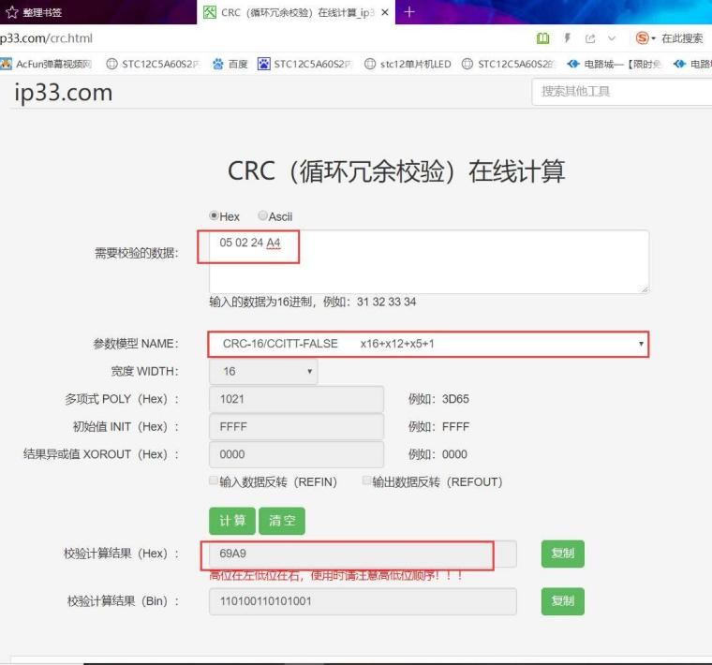

//****************************************************

//** Function name: CRC16Check

//** Input: buf The data to verify;

//** len The length of the data to verify

//** Output: Check value

//** Function description: CRC16 cyclic redundancy check

//** Note: The check mode is CRC16/CCITT-FALSE, pay attention to the variable type

//*****************************************************/

unsigned int CRC16Check(unsigned char *buf, unsigned char len)

{

unsigned char i, j;

unsigned int uncrcReg = 0xFFFF;

unsigned int uncur;

for (i = 0; i < len; i++)

{

uncur = buf[i] << 8;

for (j = 0; j < 8; j++)

{

if ((int)(uncrcReg ^ uncur) < 0)

{

uncrcReg = (uncrcReg << 1) ^ 0x1021;

}

else

{

uncrcReg <<= 1;

}

uncur <<= 1;

}

}

return uncrcReg;

}

Change Notification:

1. Replace the content data of the fifth point agreement to the original data format:

ALC: 0~34 (ALC table for BIT7, 01 for BIT6)

ADU: 0~34 (ADU table for BIT7, ADU table for BIT6 10)

After change:

ADU: 0~34 (ALC table for BIT7, 01 for BIT6)

ALC: 0~34 (ADU table for BIT7, 10 for BIT6)

## **Note:**

1. The standing wave higher than 1.5 transmission is prohibited in the full frequency band, especially in the UV segment, and the high standing wave emission is easy to damage the station. Confirm that the antenna standing wave is below 1.5 before transmission.

2. There is no high standing wave emission protection in the UV segment, and it is necessary to confirm that the antenna standing wave is lower than 1.5 before transmission.

3. The charger is only used for charging, not for direct power supply.

4. Charging requires the use of original chargers, and it is forbidden to use other brand chargers.

5. The maximum input voltage of the USB port is 5V.

6. The battery is forbidden to be exposed to the sun and used in a high temperature environment.

7. It is forbidden to discard the battery.

8. It is forbidden to throw the battery into the fire.

9. The battery is not used for a long time, and it needs to be fully charged every month, and if it is not charged for a long time, it will cause battery damage.